EXPERIMENT NO. 2 / 3
Data Flow Diagrams (Level 0, Level 1 & Level 2) & Data Dictionary
Project: Hospital Management System (HMS)
Prepared by: Anish Chitnis (24CE1044) | Aaryan Choube (24CE1045) | Somansh Dafade (24CE1047)
Batch: A / A1 | Dept of Computer Engineering, RAIT, DY Patil University
1. Aim
To develop the Data Flow Diagrams (Context Level 0, Level 1, and Level 2) and prepare a comprehensive Data Dictionary for the Hospital Management System (HMS).
2. Objectives
• To understand the functional flow of healthcare and billing data across organizational boundaries.
• To model external entities, processes, data stores, and data flows using standard Gane-Sarson / DeMarco DFD notations.
• To decompose high-level processes into detailed functional sub-processes (Level 2 decomposition of Billing & Payment).
• To establish a comprehensive Data Dictionary cataloging all data stores, composite data flows, and atomic data elements.
3. DFD Notations Used
Notation Element | Geometric Symbol | Function in HMS
External Entity | Rectangle | Source or destination of data outside system boundary (e.g., Patient, Doctor, Payment Gateway).
Process | Circle / Rounded Rectangle | Transforms incoming data flows into outgoing data flows (e.g., 1.0 Patient Registration).
Data Store | Open-ended Rectangle / Database | Persistent repository holding healthcare records (e.g., D1 Patient Master, D6 Billing Store).
Data Flow | Directed Arrow | Pipeline carrying structured data packets between entities, processes, and data stores.

4. Level 0 DFD (Context Diagram)
The Context Diagram establishes the boundary of the Hospital Management System, portraying it as a single central process (0) communicating with six external entities: Patient, Receptionist, Doctor, Pharmacist & Lab Technician, Administrator, and the Payment Gateway.
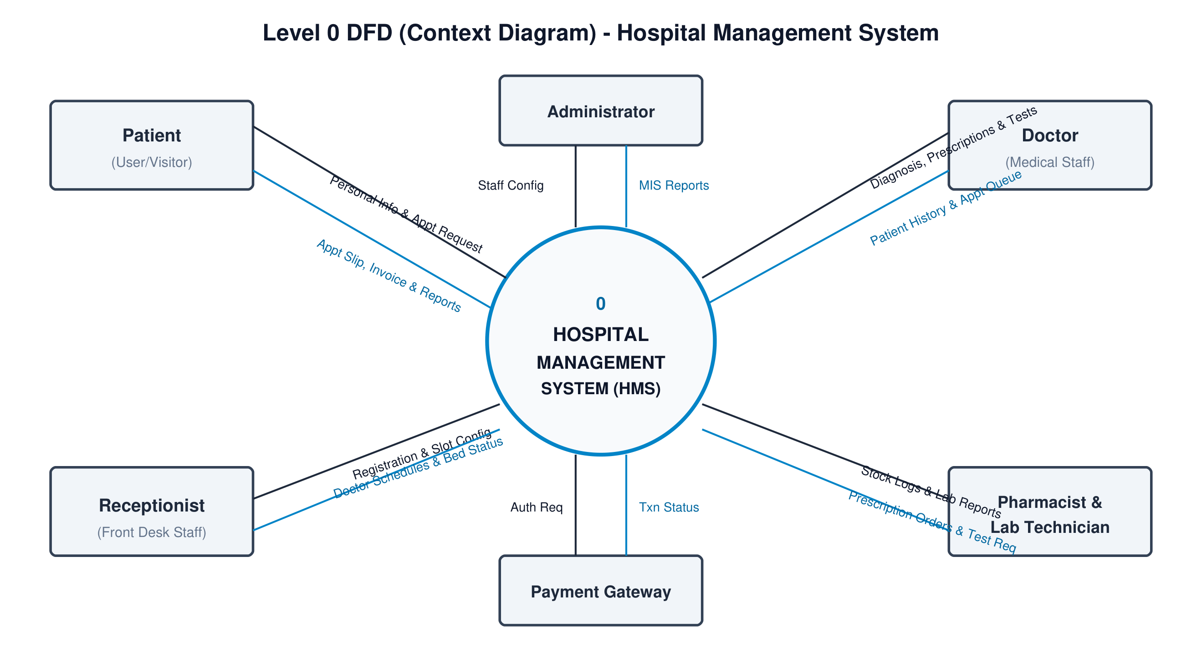
Fig 1: Level 0 DFD (Context Diagram) - Hospital Management System
5. Level 1 DFD (Decomposition into Functional Modules)
The Level 1 DFD decomposes the system into six core operational processes and seven centralized data stores:
• 1.0 Patient Registration & Appointment Management (Stores into D1 Patient Master & D2 Appointment Schedule)
• 2.0 Doctor Consultation & EHR Management (Reads D1, writes D3 Medical Records, triggers Lab & Pharmacy)
• 3.0 Laboratory & Diagnostic Management (Receives orders, writes to D4 Lab Reports Store)
• 4.0 Pharmacy & Stock Inventory Management (Reads/writes D5 Pharmacy Stock Store)
• 5.0 Billing & Payment Processing (Aggregates costs from D3, D4, D5, communicates with Payment Gateway, writes D6 Invoices)
• 6.0 Hospital Administration & MIS Reporting (Audit trail in D7, system monitoring)
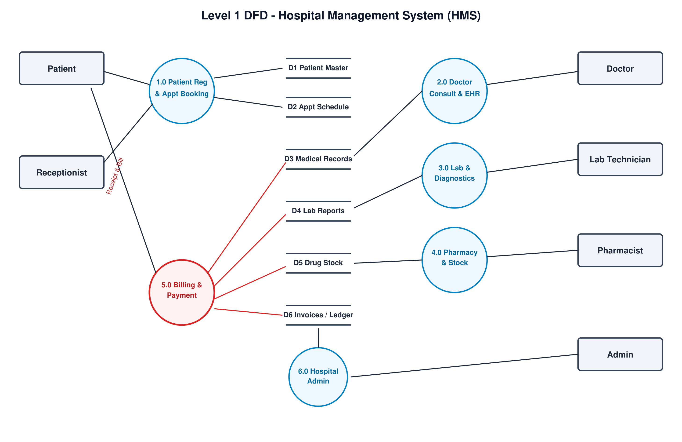
Fig 2: Level 1 DFD - Hospital Management System (Functional Decomposition)
6. Level 2 DFD (Decomposition of Process 5.0: Billing & Payment)
Process 5.0 is expanded into four sub-processes to reveal the inner mechanics of financial transactions:
• 5.1 Aggregate Service Charges: Combines Doctor Consultation Fee (from D3), Lab Investigation Charges (from D4), and Dispensed Medicine Costs (from D5).
• 5.2 Verify Insurance & Apply Discounts: Validates patient policy credentials and applies insurance co-pay discount rules.
• 5.3 Process Payment Transaction: Handles cashier cash reception or transmits digital token to external Payment Gateway.
• 5.4 Generate Itemized Invoice & Update Ledger: Updates accounting ledger D6 and generates digital receipt for Patient.
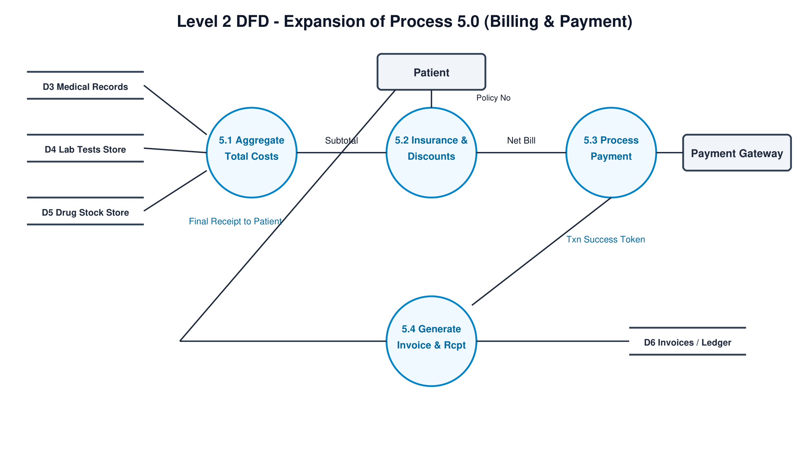
Fig 3: Level 2 DFD - Decomposition of Process 5.0 (Billing & Payment Processing)
7. Data Dictionary
7.1 Data Store Dictionary
Store ID | Data Store Name | Contents & Field Structure
D1 | Patient Master Store | Patient_ID, Name, DOB, Gender, Contact_No, Address, Blood_Group, Emergency_Contact
D2 | Appointment Schedule | Appointment_ID, Patient_ID, Doctor_ID, Appt_Date, Time_Slot, Booking_Status
D3 | Medical Records & EHR | Record_ID, Patient_ID, Doctor_ID, Diagnosis, Symptoms, Prescription_ID, Consultation_Date
D4 | Laboratory Reports | Test_ID, Patient_ID, Doctor_ID, Test_Name, Sample_Type, Test_Result, Status, Date
D5 | Pharmacy Inventory | Medicine_ID, Brand_Name, Category, Stock_Quantity, Unit_Price, Batch_No, Expiry_Date
D6 | Invoices & Ledger | Bill_ID, Patient_ID, Consultation_Fee, Lab_Cost, Med_Cost, Discount, Net_Payable, Txn_ID, Status
D7 | Staff & Audit Log | User_ID, Employee_ID, Role, Password_Hash, Action_Logged, Timestamp, IP_Address

7.2 Data Flow Dictionary (Composition)
Data Flow Name | Composition Formula ( = composed of + )
Patient Registration Info | Patient_Name + DOB + Gender + Contact_No + Address + Blood_Group
Appointment Request | Patient_ID + Doctor_ID + Preferred_Date + Preferred_Time_Slot
Electronic Prescription | Prescription_ID + Patient_ID + Doctor_ID + {Medicine_Name + Dosage + Duration} + Instructions
Diagnostic Test Requisition | Test_ID + Patient_ID + Doctor_ID + Test_Name + Priority_Flag
Itemized Invoice & Receipt | Bill_ID + Patient_ID + Date + Fee + Lab_Cost + Med_Cost - Discount + Net_Amount + Txn_Token

8. Conclusion
The multi-level Data Flow Diagrams and Data Dictionary provide a rigorous structural blueprint of data movement throughout the Hospital Management System. The Level 2 expansion of billing confirms precise integration between clinical departments and automated accounting.

